Adding a job

Now that everything is up and running, it's time to create our first job. Click the New Job link:

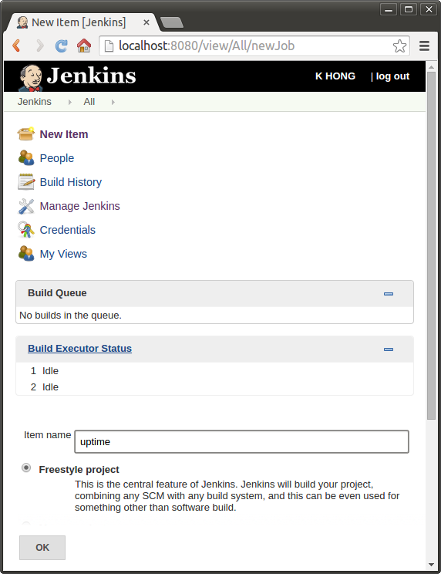

Press Ok and on the next page, add a Execute shell build step:

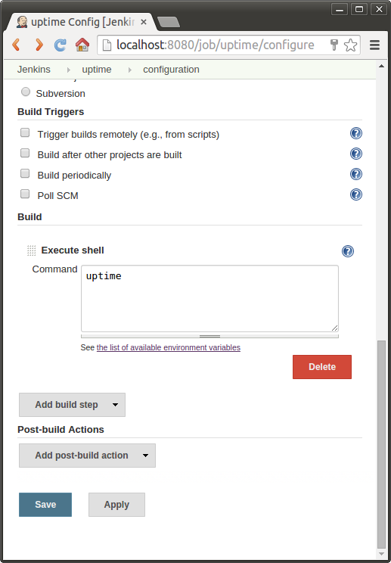

Click the 'Save' button at the bottom of the screen.Bottom of Form

Build

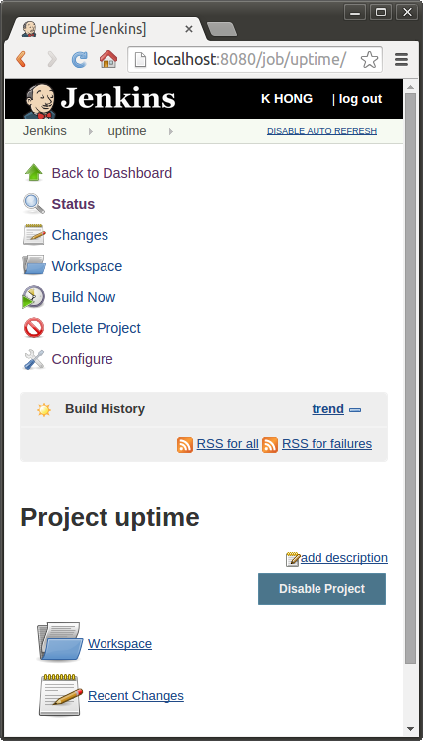

Click the 'Build Now' button, then we can see the build show up in the build history block. Click the blue sphere for the console output: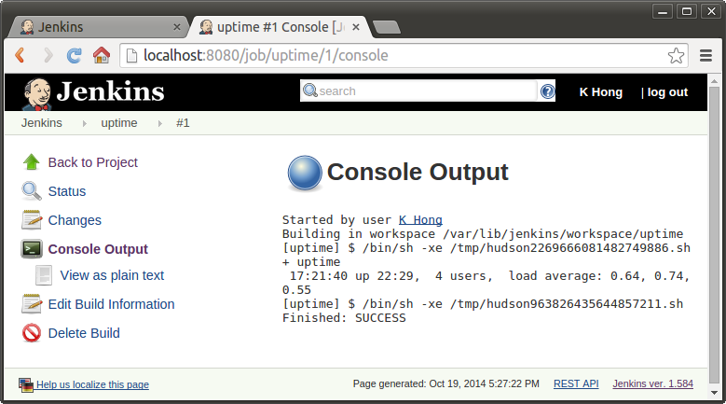

Scheduling jobs

Jenkins can run our job either on-demand or at a scheduled time. Since we've set up the basic build, it's time to configure a build schedule. First, click the 'Back to Project' link to return to the job overview:

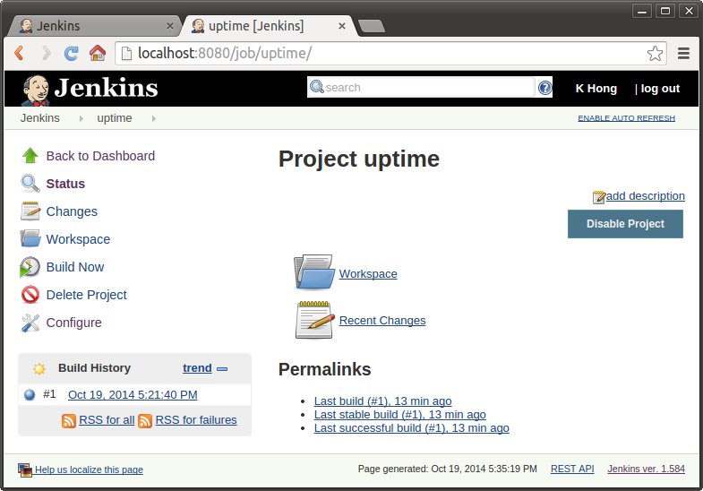

Press the 'Configure' button which leads us to the configuration page. Now look for 'Build Triggers' and check 'Build periodically':

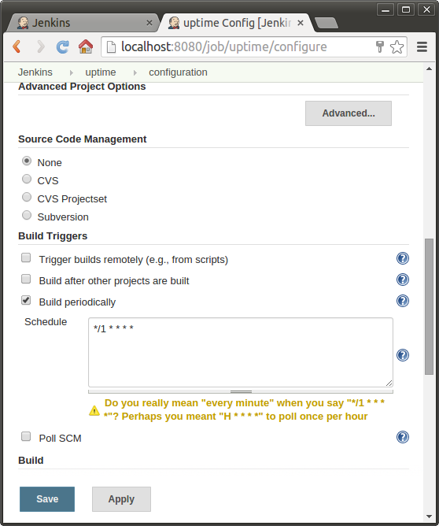

Now this input field accepts the 'cron' syntax, We'll set it to 0/1 \* \* \* \*, starting it every every minute. When the job is saved, the scheduler will start the job at its designated times. We can check the job scheduled every minute indeed ran as expected.